**GIT Remoting**

**Objective: Pushing source code into GITHUB & collaborate team members**

**SECTION-1 (Pushing assignments to remote repository)**

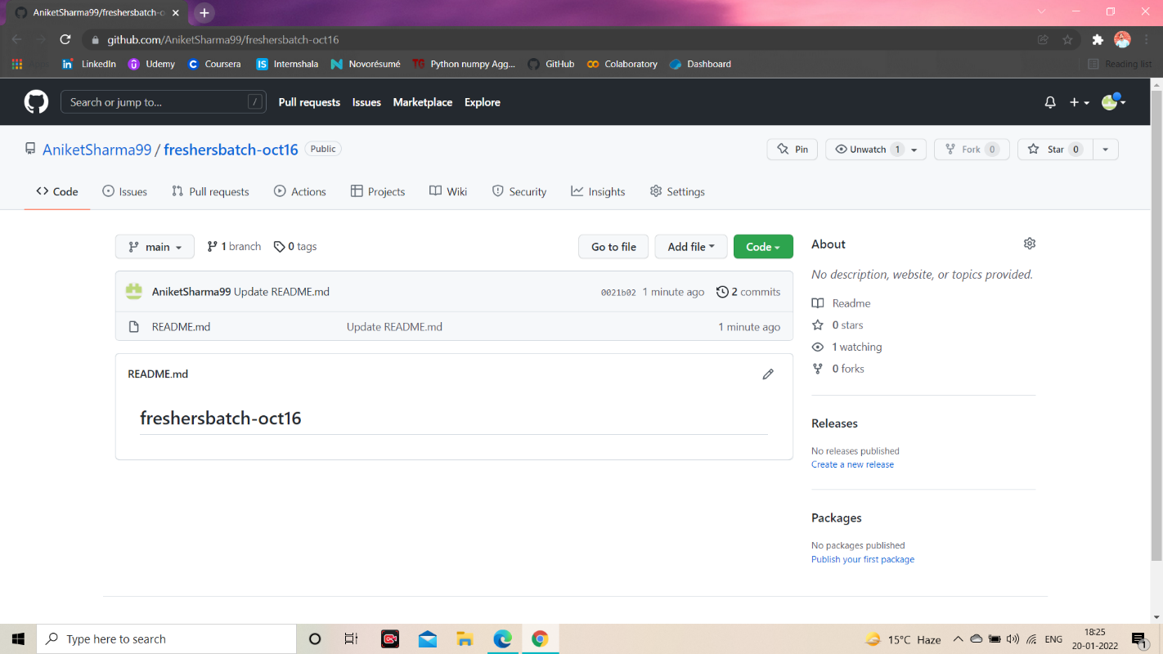

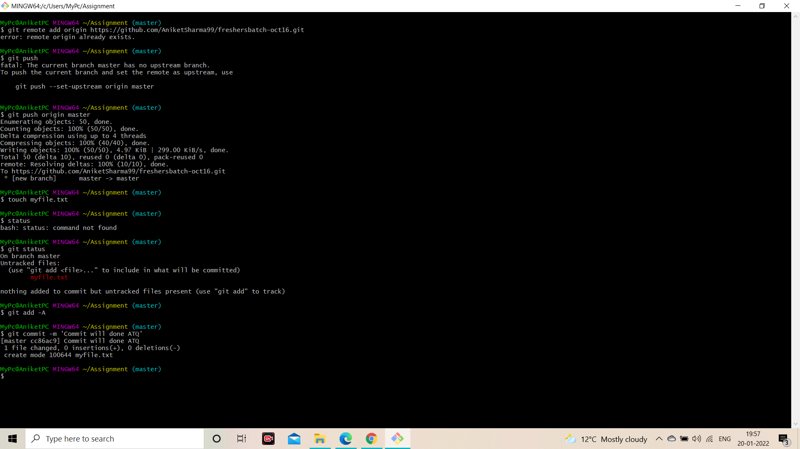

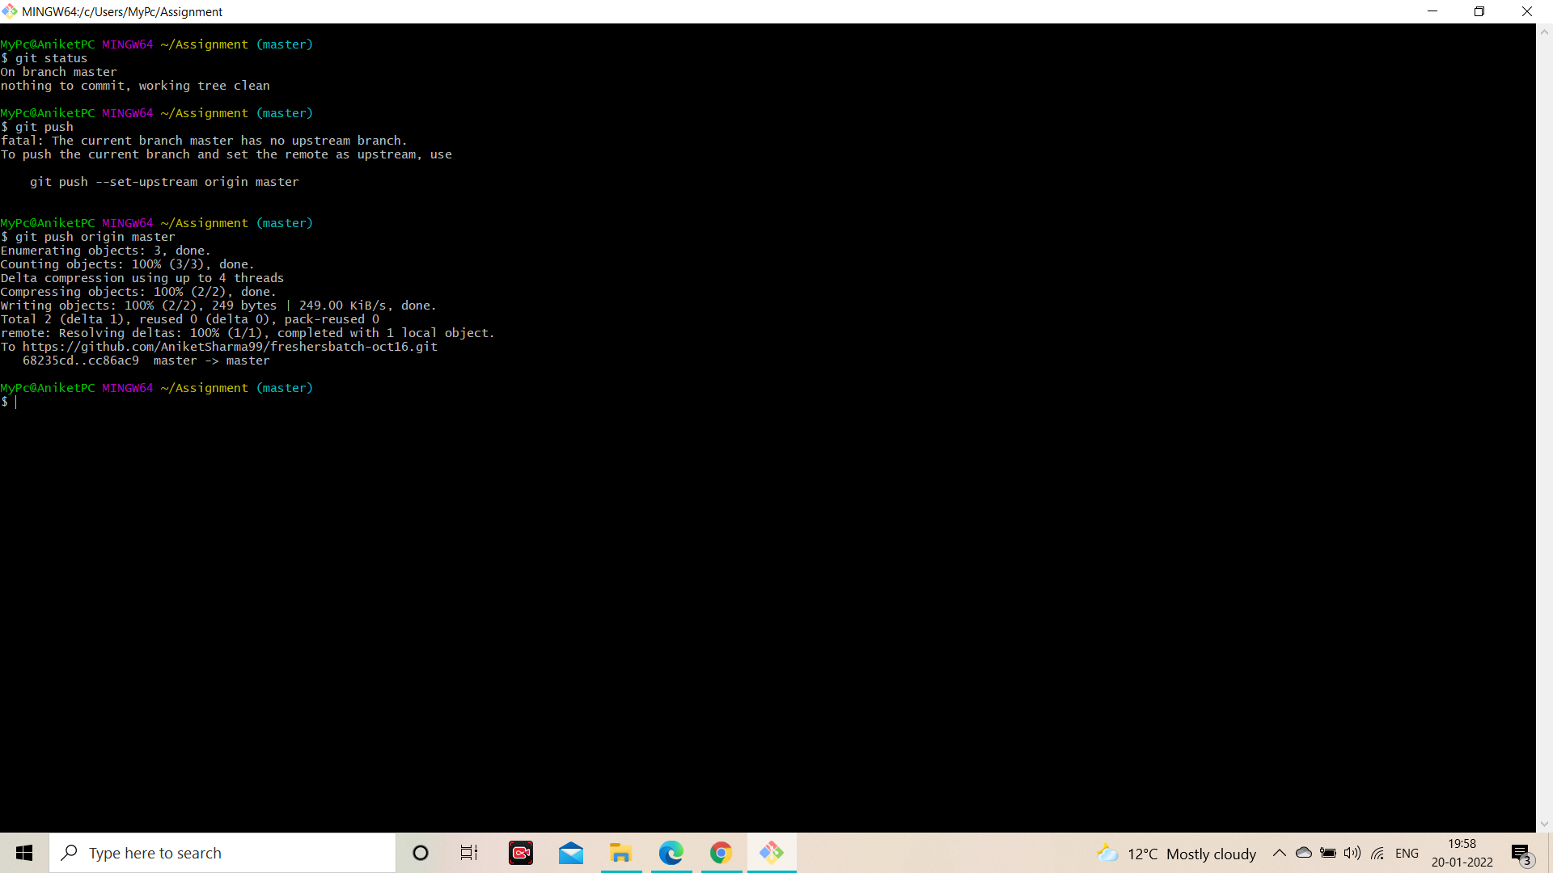

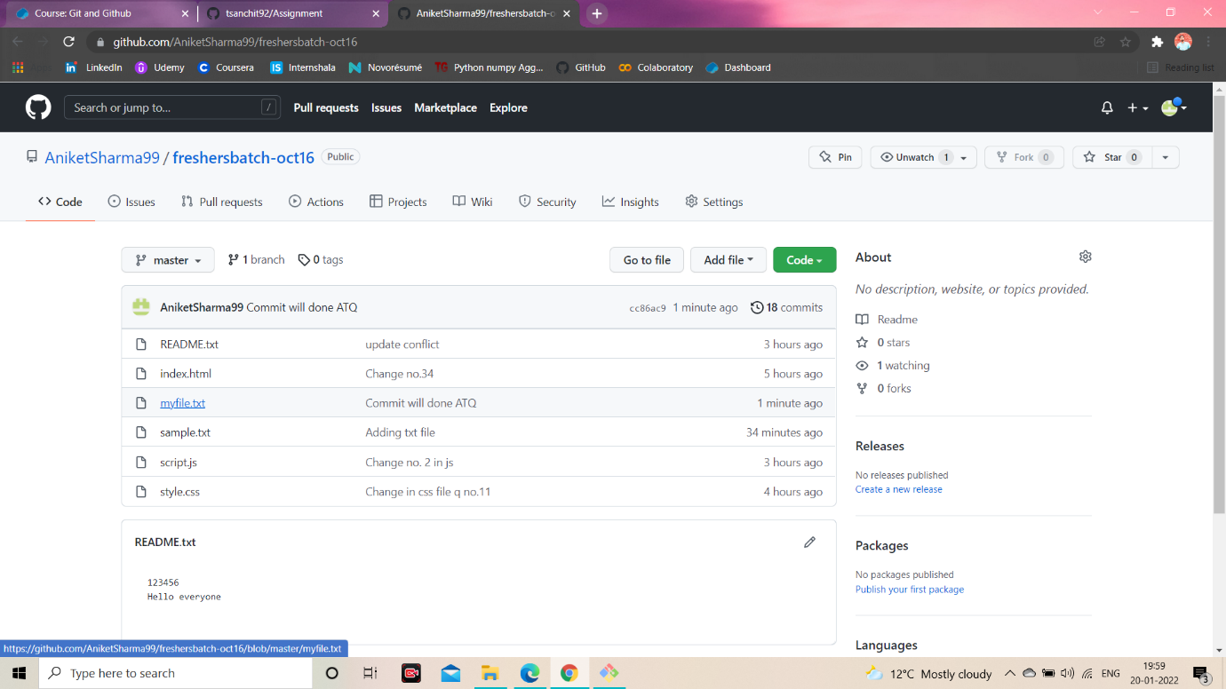

**SECTION-2 (Pushing source code to remote repository using Eclipse GIT plugin)**

